* EirRings

May 5, 2017

Dear Friends,

The pupils of Fifth and Sixth Class of Scoil Mhuire NS, Bornacoola, have been participating in the Junior Entrepreneur Programme 2017. In this exciting programme we had to go through a staged project development process in order to arrive at a product that could be marketed and sold, and in the process make a small profit!! We went through a Dragons Den event in the school at which our ideas were aired and we ultimately decided on one product to produce at school and sell. The idea was EirRings, which involves producing a key ring with your personal Eircode on it. How many times have you been asked for your Eircode and you are not able to recall it?? This simple device will solve all your problems!!

We are delighted now to inform you that our product has been produced and is ready for order. We would be very pleased if you could help us complete the venture by ordering an EirRing for your use and convenience. You may return this order form if you are interested directly to the school or by email to [scoilmhuirensbornacoola@gmail.com](mailto:scoilmhuirensbornacoola@gmail.com) . Any enquiries may be made directly to the school at 071-9638441.

**In order that we may complete your personalised EirRing, we need the following information from you by completing the order form below. You can look up your Eircode at** [**https://finder.eircode.ie/#/**](https://finder.eircode.ie/#/) **and once we have that information we will complete your personalised EirRing pictured below:**

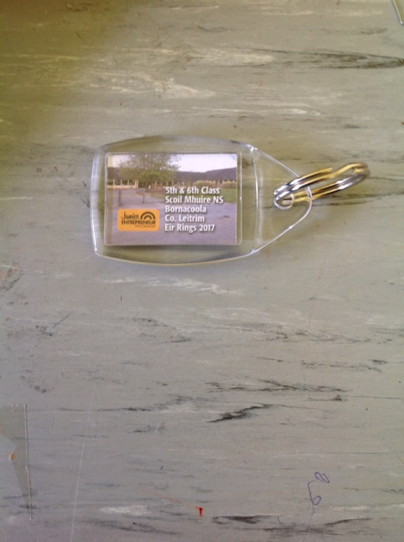 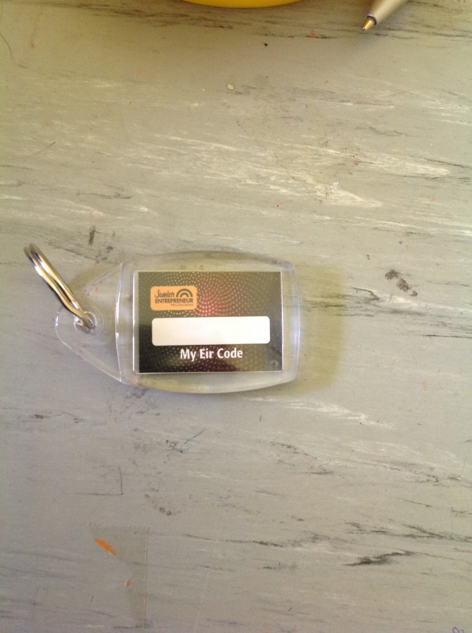

We will assemble this at school. We would appreciate early orders to ease production pressure!!!!

**Order Form**

Name: _____________________________________________

Eircode: _____________________________ Number ordered: _______________

Phone Number: ____________________________

Price:

One for €2.99 Two for **€4.99 Three for €5.99**